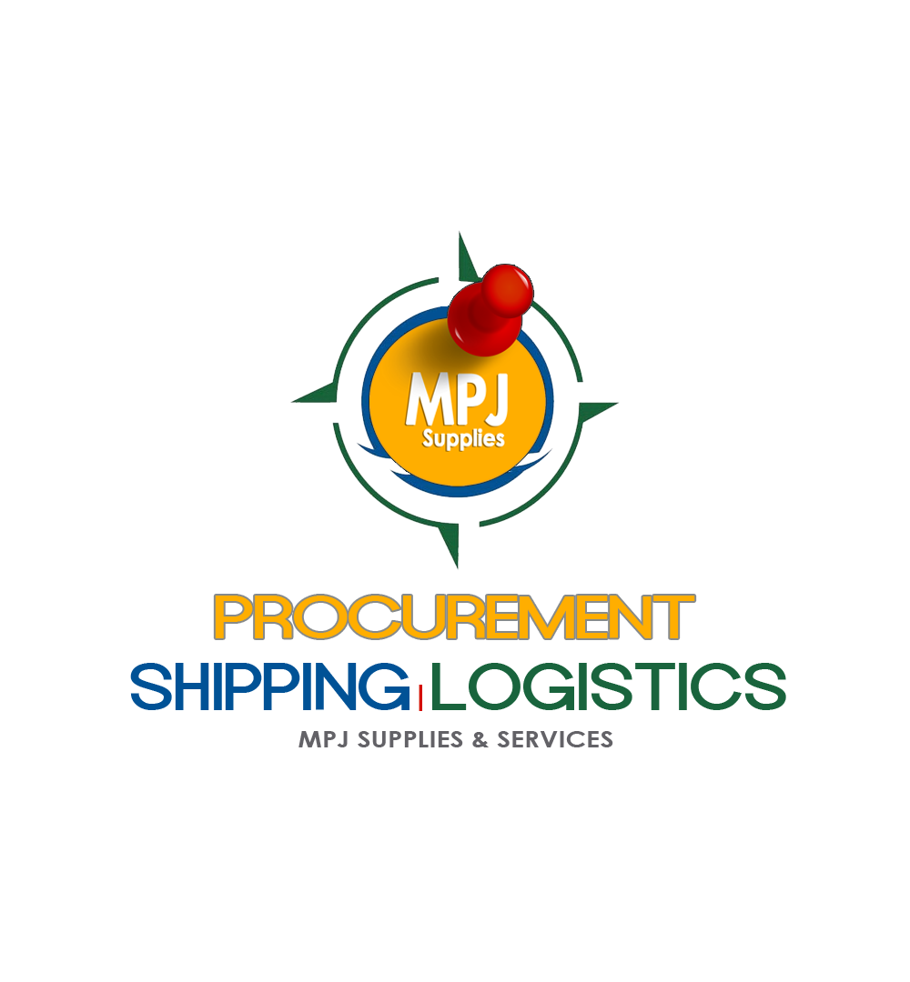



MOCKUP REQUIRED

INITIAL PAGE:

Create Account / Login:
- Admin Login
- User / Customer Login

- ADMIN
>Select Role
Choose from:
- Associate Login
  - Warehouse / Office Associate – Login to start receiving shipments.
  - Vendor Login – For other independent hubs that would receive cargo on our behalf, to be shipped. Input local notifications etc.

- Master Login (Owner / Director login – able to access and edit all sections.
  - Input all notifications etc.

Note: Login description may pop up with (i) hover.

MOCKUP REQUIRED

Creating a USER / Customer Account:
Create an Account Page

First Name*
Middle Name
Last Name*
Company Name
Place of Employment
Email*
Mobile Number*
Phone Number
Date of Birth
National ID
Destination Country:*
Destination Address:*
Select HUB: (options populated from Master created HUBs)
Preferences:
Consolidate my shipments: Your items are held in an assigned section of warehouse pending receipt of additional goods or instruction from shipper – to be consolidated and shipped at a later date. Subject to HUB / Vendor approval.
Receive & Ship: always ship packages on the next available ship date.
Preferences & Notes:

Once filled / complete, a Box ID is generated with country acronym as prefix. For example, Trinidad would be TNT-1234 or 868-1234
St. Vincent would be SVG-1234
Barbados would be BDS-1234.

Notification email sent to User – Thank you for choosing (Vendor Name). Below is your account details. Be sure to record / save your username and password to login your account.
Address for future shipments:
Name
Address Line 1:
Address Line 2: MPJ TNT-1234
City
State
Zip
Contact: Hub Phone Number

Your Local Office:
Office Name, location, contact number & email. (Assigned from Master)

USERNAME: (Box ID)
Password: Autogenerated? (see tech).
MOCKUP REQUIRED

Creating an Associate Account:

First Name*
Middle Name
Last Name*
HUB Name
Email*
Mobile Number*
Phone Number
Date of Birth
Preferences & Notes

Once filled / complete, a LOGIN is generated with HUB as prefix. For example,
Hallandale Hub would be HAL-1234
New York Hub would be NYC-1234

USERNAME: HAL1234
Password: Autogenerated? (see tech).

  - LOGIN
  - Cycle Sections

MOCKUP REQUIRED

Creating a Vendor Account:

First Name*
Middle Name
Last Name*
Business Name*
Company Name* (as per registration)
HUB Name
HUB Location* (address)
Email*
Mobile Number*
Phone Number
Date of Birth
Preferences & Notes

Once filled / complete, a LOGIN is generated with HUB as prefix. For example,
Hallandale Hub would be HAL-1234
New York Hub would be NYC-1234

USERNAME: HAL1234
Password: Autogenerated? (see tech).

Master Account Login

Create / Register Vendor HUBs in system.
Create / Register Local Offices in system.
  - Can view & edit all sections – both admin and users
  - Once logged in, screen should see / be able to choose:
    - Master hub
    - Select hub,
    - Cargo – here you see the received cargo and its assignment to each hub. You can also see the country they are assigned to.
    - Shipments – this is tally, log and list of passed shipments.
  - Must be able to send mass announcements / notices on Hub Closures, Holiday hours, Shipment updates / changes etc. (let’s discuss if this should be approached as a marketing post or ad.)

MPJ LOGISTICS – Wireframe Outline - OP

Cycle Sections:

- RECEIVING
- PACKING & CONSOLIDATING
- LOADING
- SHIPPING

RECEIVING – 2 ways MOCKUP REQUIRED

- Courier Drop off
- Customer Drop Off

- Courier Drop Off
- Package received
- Received in good condition? Select – Yes / No
- Package scanned
- Enter customer name – last or first name. System must auto-populate / bring up possible customer from customer base
- Insert date received, package weight, size (in units as required), courier and sender / manual entry.
- Scan Tracking number Barcode
- System then requests package contents / description before you can move to next step.
- Once done, Package is assigned a number & QR code
- Prepaid / freight collect? – Freight Collect (Default) once in the courier drop off section.
  - Here, there is an option to print label. Label would include all inputted information, as well as additional information prefilled from the customer account preferences – including the default country and shipping method.

- Once code is assigned, system prompts use to assign its warehouse location.
- Assign section in warehouse.
(notes - location in this case would be where the box can be found / placed.)
Pre-assignments:
- Ocean Section
- Air Section
- Hold Section
- Specify Bin (open for manual fill notes).

SAVE
Customer receives email notification – Your shipment has been received at warehouse.
MOCKUP REQUIRED

Based on the information inserted, an estimated freight cost is automatically generated.

  - Customer Drop Off
- Package Received
- Received in good condition? Select Click – Yes / No
- Weight & Dimension recorded. – system generates cuft / dimensional weight.
- Enter customer name – last or first name. System must auto-populate / bring up possible customer from customer base
- Insert date received, package weight, size (in units as required) sender / manual entry.
- Scan Tracking number Barcode
- System then requests package contents / description before you can move to next step.
- Once done, Package is assigned a number & QR code.
- Prepaid / freight collect?
  - Here, there is an option to print label. Label would include all inputted information, as well as additional information prefilled from the customer account preferences – including the default country and shipping method.
- Once code is assigned, system prompts use to assign its warehouse location.
- Assign section in warehouse.
(notes - location in this case would be where the box can be found / placed.)
Pre-assignments:
- Ocean Section
- Air Section
- Hold Section
- Specify Bin (open for manual fill notes).
SAVE

Customer receives email notification – Your shipment has been received at our SF warehouse. MOCKUP REQUIRED

Based on the information inserted, an estimated freight cost is automatically generated.

PACKING & CONSOLIDATING MOCKUP REQUIRED

Next – customer has the option (selected in customer profile ) if they are Basic – then nothing is required.
For consolidation clients:
- Open New Consolidation
- Select Customer Name / Account
- Select Container. Choose from:
  - Barrel
  - E Container
  - C Container
  - D Container
  - Box
  - FCL – 20ft Container
  - FCL – 40ft Container
- That selected container would be auto assigned a QR Code.

Load Container: fields to scan packages (previously assigned) is now available.

All scanned packages are now in assigned container.

Select:
- Close Container
- Add more items (providing that container is not filled or incomplete)
Once Closed, Select:
- Ship VIA
  - OCEAN
  - AIR

PRINT: Options
- Print Label will include predetermined info including shipper, sender and final destination.
- Print QR Code ONLY
- Generate manifest - this can be downloaded in XL
- SAVE

Next:
- Open New Consolidation
Please note that a container manifest must be able to be generated at any given time by user. (options available in menu)

Customer receives notification: Your package has been processed at warehouse and ready to be shipped out.
Please upload any relevant documentation for you shipment including invoices, declarations, etc.

LOADING MOCKUP REQUIRED

Used to recall which truck, date etc a completed container leaves the warehouse.

SHIPPING MOCKUP REQUIRED

Manager must see all COMPLETED CONTAINERS – Pending ship date assignments.

Ensure that
- Each containers Is labelled with relevant information.

For Ocean Shipments,
Choose from:
  - TROPICAL SHIPPING
    - Enter tracking / warehouse receipt number
    - Save
  - KING OCEAN MARTINER
    - Enter tracking / warehouse receipt number
    - Save
  - CARIBTRANS
    - Enter tracking / warehouse receipt number
    - Save
  - SEACO
    - Enter tracking / warehouse receipt number
    - Save
  - Other (manual entry)
    - Enter tracking / warehouse receipt number
    - Save

For Air Shipments
Choose from:
  - Amerijet
    - Enter tracking / warehouse receipt number
    - Save
  - Caribbean Airlines
    - Enter tracking / warehouse receipt number
    - Save
  - Fedex
    - Enter tracking / warehouse receipt number
    - Save
  - UPS
    - Enter tracking / warehouse receipt number
    - Save
  - DHL
    - Enter tracking / warehouse receipt number
    - Save
  - Other (manual entry)
    - Enter tracking / warehouse receipt number
    - Save

Customer receives notification: Your shipment has been loaded MOCKUP REQUIRED

Note:
System should not let you move to a next SECTION, unless current mandatory fields are fully filled. Offer a “Cancel Entry” option.

SHIPMENT ARRIVAL MOCKUP REQUIRED

- Once container has arrived in island office, the container QR Code must be scanned. This will send an auto-notification to Customer & ALL HUBS that the master shipments has reached the destination.
- Each package is scanned by local vendor / office – confirming that shipment is now there.
  - There are fields to add additional information on
    - shipping charges
    - brokerage & other fees
    - import duties
    - delivery / transportation etc.
- Invoice Closed
Customer receives notification – Your shipment is ready for pickup at local office. Your invoice total is____. Login to view entire invoice.
Please pickup at your earliest convenience to avoid storage fees.
Thank you for choosing (Office Name).
Powered by iTrack. MOCKUP REQUIRED

